**Executive Summary**

This project examined if there is a concentration of children with ADHD in any state or region of the U.S. and if there were correlations in environmental factors. The dataset, 2021 National Survey of Children’s Health, was retrieved from the national census bureau. The data contained information about U.S. children as reported by their parent or guardian. Analysis found 66% of reported ADHD children are male and 33% female. Louisiana, Mississippi, and South Carolina showed an elevated concentration of reported ADHD children. No statistically significant discoveries of environmental or household data were found during analysis.

## Introduction

Attention Deficit Hyperactivity Disorder (ADHD) is described by the CDC as a neurodevelopmental disorder first diagnosed in childhood and extending into adulthood. Environmental factors may contribute to the causes of ADHD (Songua et al., 2023). This project aimed to determine if there is a correlation between residence state/region/environment and diagnosis of ADHD. Analysis of the data focused on the following questions:

* Are there regions where ADHD is prevalent in the US?
* If so, are there common environmental factors in these regions?

## Data

There are limited dataset containing information about ADHD, however the National Survey of Children’s Health (NSCH) is conducted by the United States Census, Associate Director for Demographic Program. The survey provides national and state level information on physical and mental health of youth ages 0-17. This survey was retrieved from https://www.census.gov/programs-surveys/nsch/data/datasets.html.

The dataset chosen for this project was quite large with over 50k rows and almost 500 variables. It was structured in rows/columns and contained a header row with variable names. The data contained information about the household, the parent/guardian, and the child. Variables of particular interest included state of residence, child gender, ADHD diagnosis, and environment variables.

The dataset SAS file was imported into SSPS saved as a csv file. The data was then reviewed, select variables were chosen (see Appendix), columns were renamed, and dataset was saved again. The cleaned csv was then imported into R where two data frames were created: one with the total data, titled “nsch”, and a second with only the data of the children with ADHD, titled “adhd”.

## Data Analysis

Both data frames were explored by mapping the reported population of total U.S. youth and reported U.S. youth with ADHD. The visuals show a larger population of children in the lower southeastern U.S. states of Louisiana, Mississippi, and South Carolina.

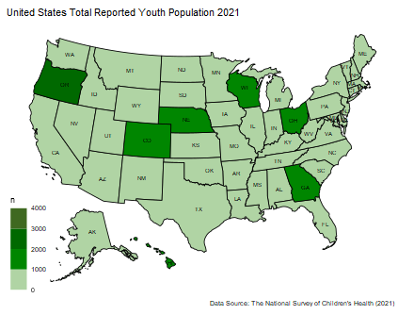

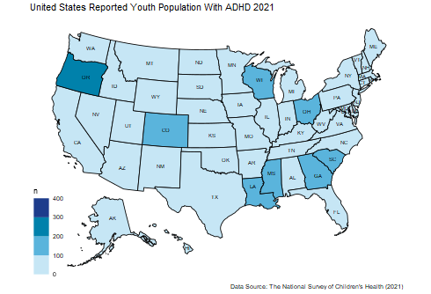

Given this information, it was decided to examine the children in southern states (LA, MS, and SC) for similarities and differences within the region and the other states. Summary statistics were performed on the data frames. Bar charts to compare gender were generated.

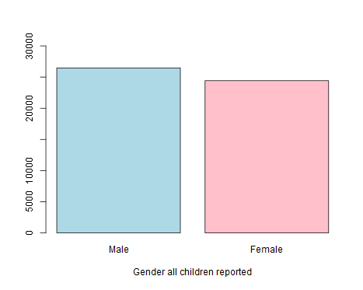

The gender of total children reported is relatively close n = 50892; male (26468) 52%, female (24424) 47.9%. The gender of reported ADHD children was quite different. Total children reported having ADHD was n = 4278. Number of male children reported to have ADHD was 2855 (66%) and reported female ADHD children was 1423 (33%).

Summary statistics reveal that the mean birth year for reported ADHD children was 2009 (age 12). The remaining variables revealed no significant discoveries when examined including race, birthweight, breastfed, WIC, reduced meals, and neighborhood and school safety. However, it was noted that the reported mean hours slept of ADHD youth was 4.3 hours. The CDC recommends 10-12 hours of sleep for children of age 3-12 and 8-10 hours for teens (2023).

## Discussion and Conclusions

Children in the survey ranged in age from 0-17. Analysis found a higher concentration of reported youth with ADHD in U.S. southeastern states of LA, MS, and SC. A higher percent of males was reported to have ADHD compared to females. Additional analysis found no correlations within the data, however, further, analysis is needed.

## References

National Center for Chronic Disease Prevention and Health Promotion, Division of Population Health. (2022). Sleep and Sleep Disorders: How much sleep do I need? *CDC*. Retrieved from https://www.cdc.gov/sleep/about_sleep/how_much  
_sleep.html

Sonuga-Barke, E. J. S., Becker, S. P., Bolte, S., Castellanos, F. X., Franke, B, Newcorn, J. H., Nigg, J. T., Rohde, L. A., & Simonoff, E. (2023). Annual Research Review: Perspectives on progress in ADHD science – from characterization to cause. *Journal of Child Psychology and Psychiatry 64:*4 (2023), pp 506–532. doi:10.111  
1/jcpp.13696.

## Appendix

Project Variables:

fips

gender

birth_yr

born_early

birth_wt

birth_wt_l

birth_wt_vl

breastfed

adhd_curr

adhd_sev

adhd_meds

adhd_behav_treat

anx_curr

anx_sev

depress_curr

depress_sev

ld_curr

ld_sev

behav_prob_curr

behav_sev

emo_med

ment_treat

ment_prob

overwt

avg_hrs_slept

errand_alone

headache

headache_sev headache_curr alt_healthcare

sports

clubs

activities

volunteer smoke_in_home food_stamps

redu_meals

wic

parent_divorced parent_died

parent_jail

adult_violent vic_violence live_with_ment_ill live_w_alcdrugs exper_racism

exper_sexism exper_health_cond easily_distracted

safe_neighbor

safe_school

race

hispanic

asian

am_ind

hawaiian

HHID